INTERGRATION TESTING REPORT

TEST SCENARIO
User registers, logs in, opens an account, performs a deposit and system stores everything in the database.

- Registration
- User should be prompted to fill the registration fields (fig 1.1)
- The newly registered customer should be inserted in the customer table in MySQL database. (fig 1.2)
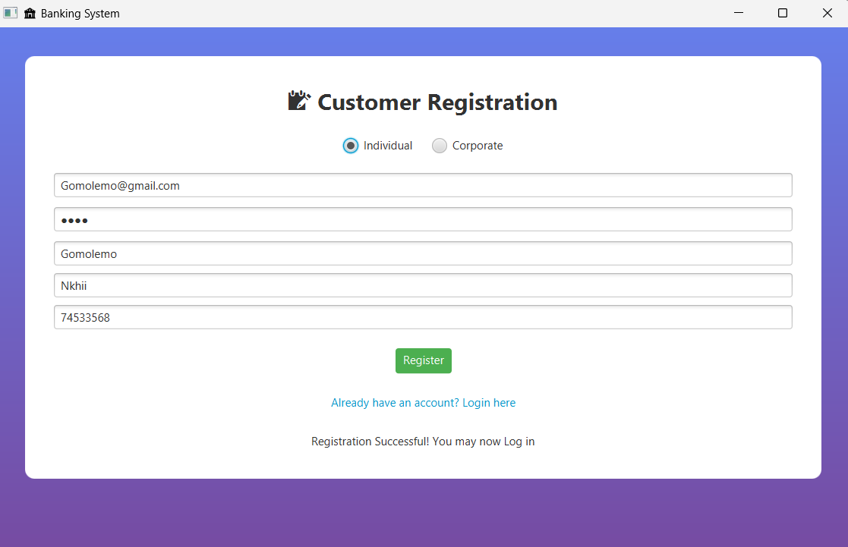fig 1.1

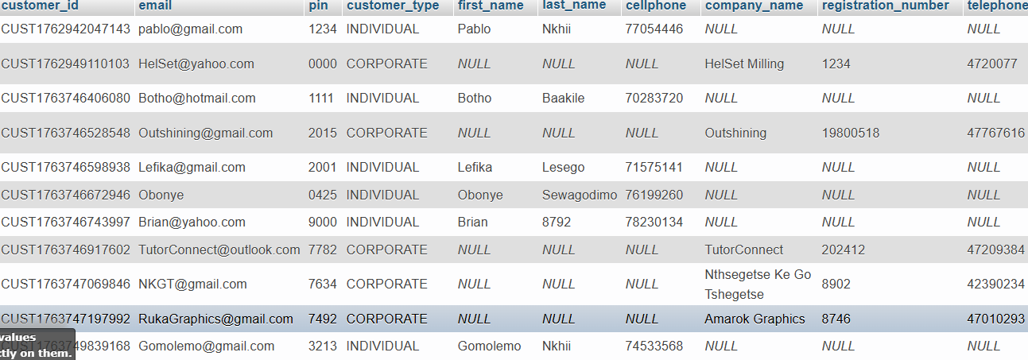fig 1.2

- Log in
- After registration, the customer should be able to login using their email and pin (fig 2.1)
- Successful log in should then take load the AccountView page. (fig 2.2)

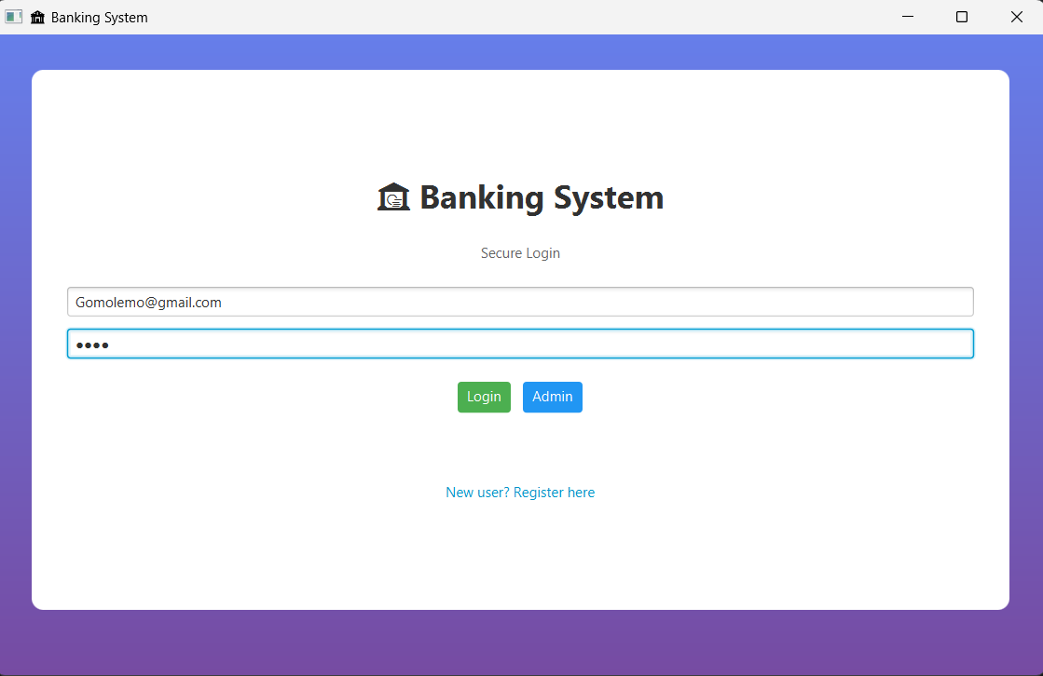
Fig 2.1

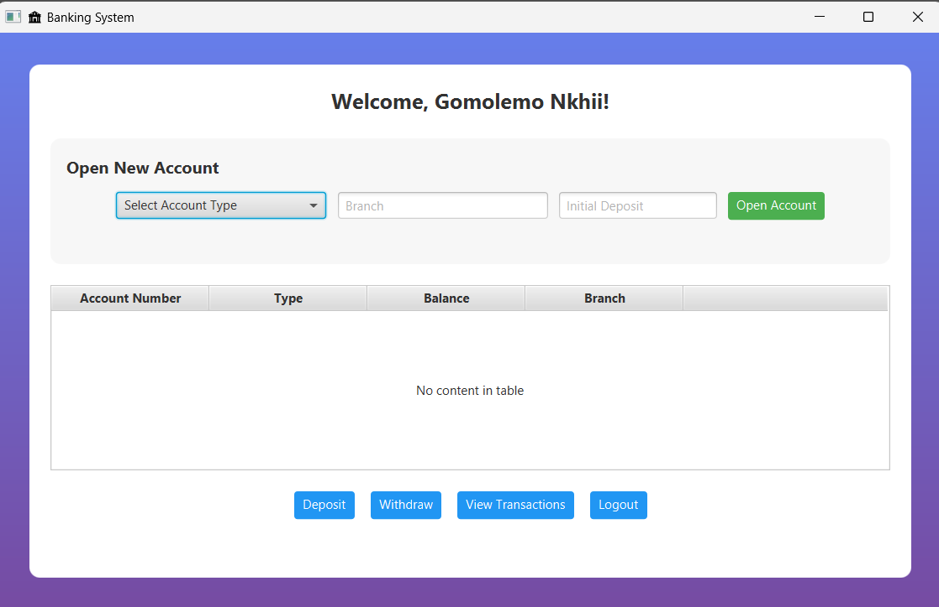fig 2.2

- Opening an Account (example, Cheque account)
- The customer should be able to choose from three accounts, cheque, investment and savings accounts then fill in the required information in the given fields. (fig 3.1 and fig 3.2)
- The created should be appear in the account table in the application as well as be inserted into the accounts table in the MySQL database. (fig 3.3 and fig 3.4)

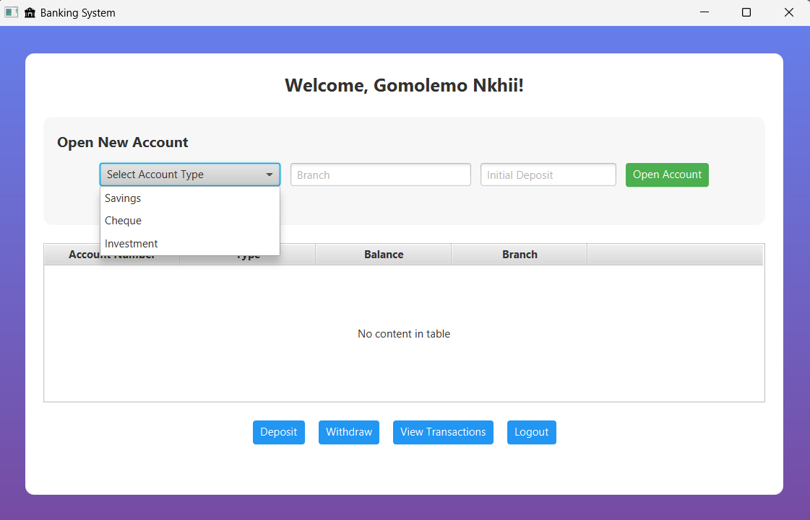fig 3.1

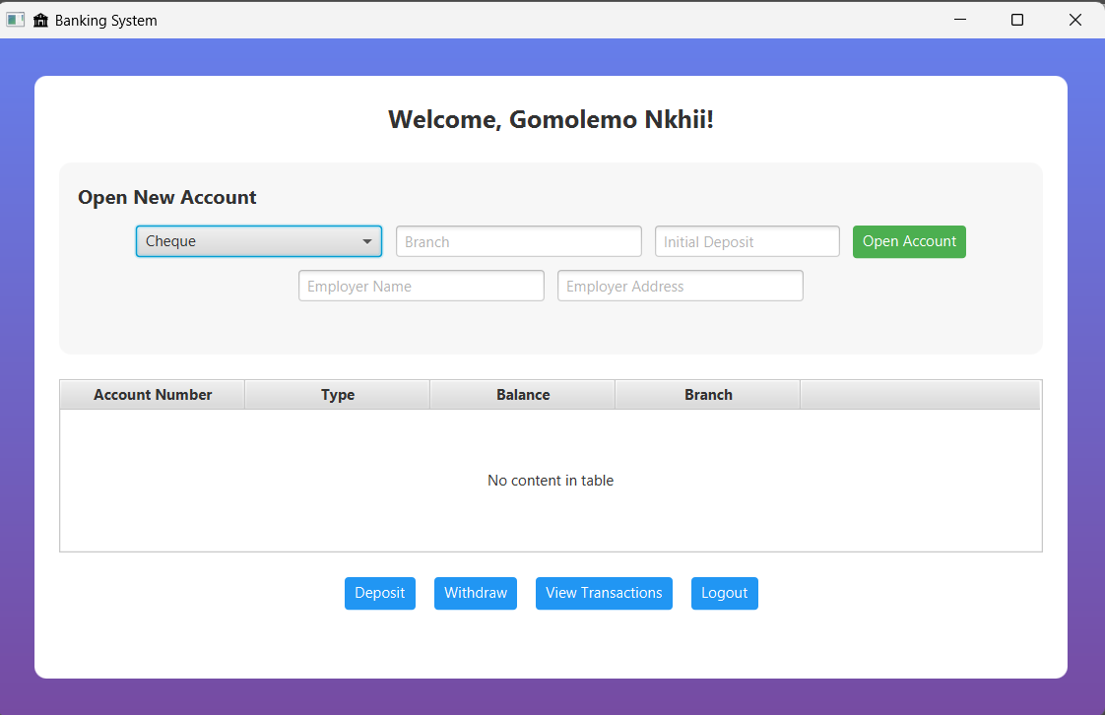fig 3.2

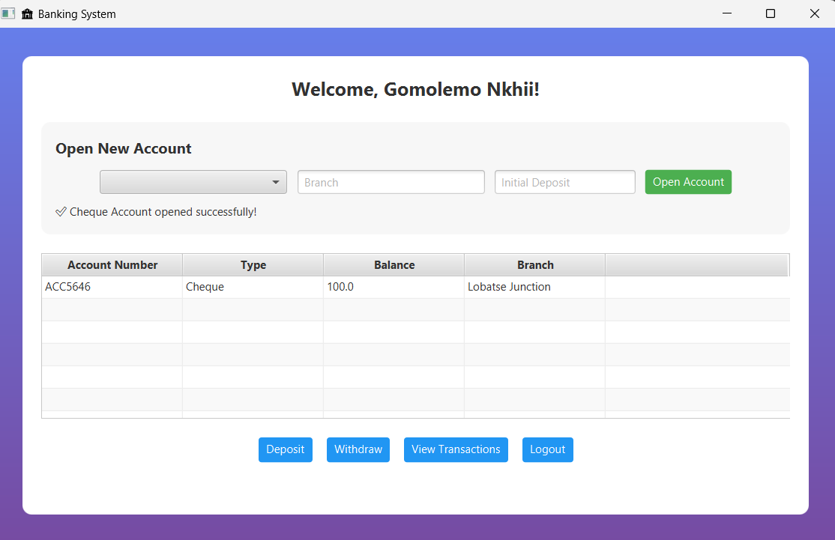fig 3.3

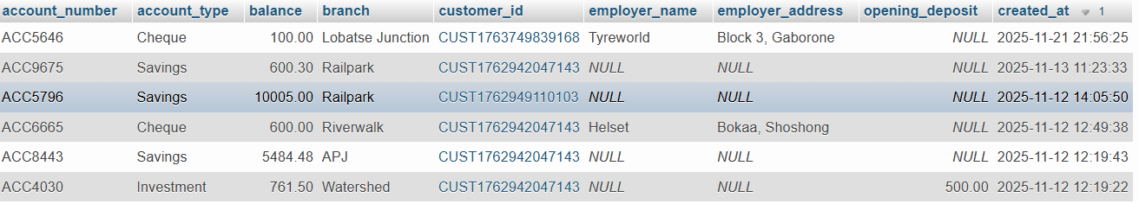fig 3.4

- Performing a transaction (Deposit)
- The user should be able to perform a transaction on a selected account (fig 4.1)
- After entering the transaction amount, the account balance should update and show the current balance. (fig 4.2)
- The transaction should be inserted in the transaction table in the database (fig 4.3)

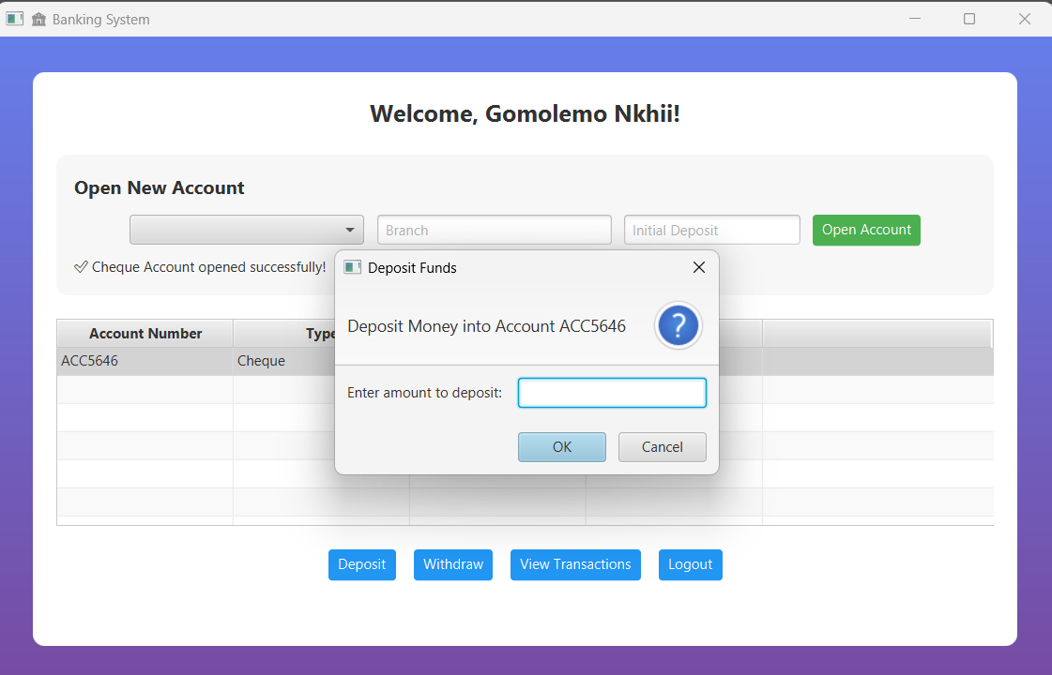fig 4.1

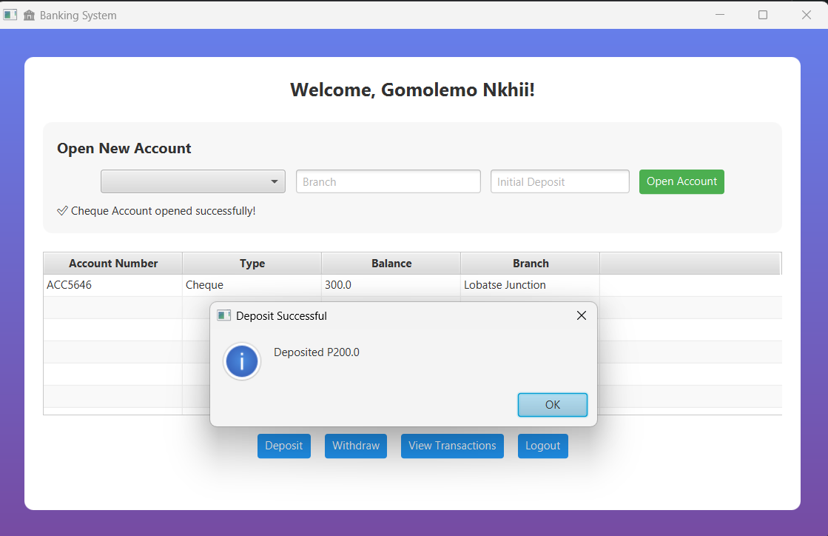fig 4.2

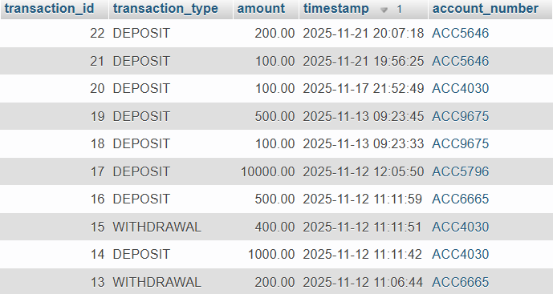fig 4.3

